CS 5200 Homework 1 Yushu Wu

1. Nouns List

|  |  |
| --- | --- |
| Course |  |
| enrollment | final grade, letter grade, student feedback |
| evaluation | simple essay assignment, submission assignment |
| everyone |  |
| exam | essay question, multiple choice question, fill in the blank question |
| Faculty | benefit, tenure status, parking, bank account info |
| grade |  |
| Lesson | calendar schedule |
| Module | calendar schedule |
| office hours | instructor, teaching assistant |
| profile information | username, password, first name, last name, email, phone, address |
| section | seat capacity |
| semester | fall, spring, full summer, summer 1, summer 2 |
| student | financial aid info, GPA, work-shop, scholarship, final grades |
| widgets | YouTube, slides, text, documentation, raw HTML |

1. Verb list

|  |  |  |
| --- | --- | --- |
| Verbs | | |
| Faculty | authors | courses |
| Course | contains | learning modules |
| Learning modules | bebroken up into | lessons |
| Course | be taught in | particular semester in a given academic year |
| Student | enroll in | section |
| Faculty | teach | section |
| Student | enroll | course |
| Everyone | be verified by | profile information |
| Faculty | update | benefits, tenure status, parking, bank account info |
| Students | verify | financial aid info, work-study, scholarship |
| Grade | be broken by | assessments |
| Registrar’s office | create | sections |
| exam | contain | essay question, multiple choice question, fill in the blank question |
| profile information | has | username, password, first name, last name, email, phone, address |



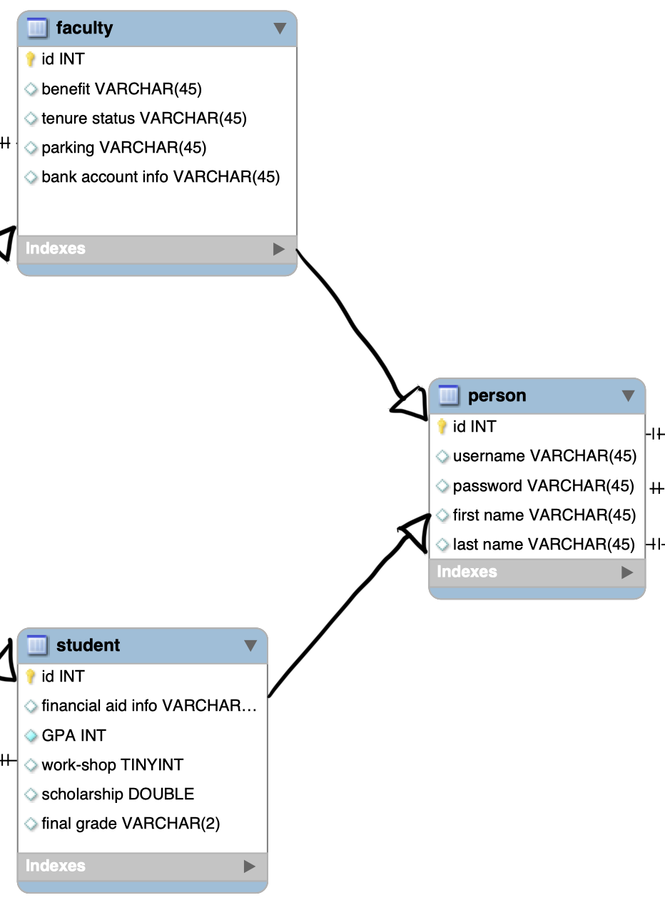

Both faculty and student are inheritances from person class, they both have those attributes that person has, while they have them unique attributes person class doesn’t have.

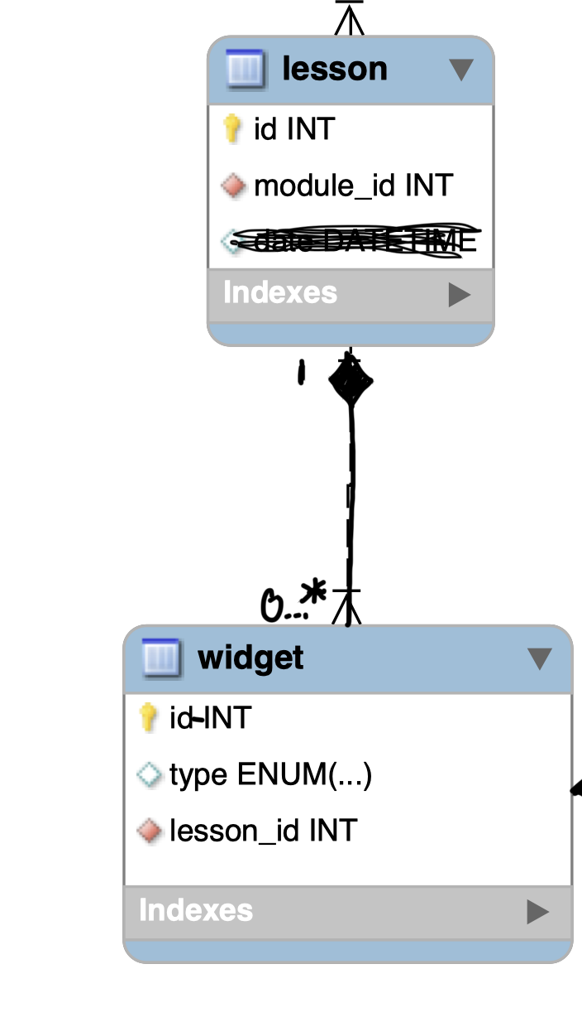

This relationship is a composition relationship. Widget cannot exist without lesson.

|  |  |
| --- | --- |
| **Classes** | **Attributes** |
| Course |  |
| enrollment | final grade, letter grade, student feedback |
| evaluation | simple essay assignment, submission assignment |
| Everyone(person) |  |
| exam | essay question, multiple choice question, fill in the blank question |
| Faculty | benefit, tenure status, parking, bank account info |
| grade |  |
| Lesson | datetime |
| Module |  |
| office hours | instructor, teaching assistant |
| profile information | username, password, first name, last name, email, phone, address |
| section | seat capacity |
| semester | fall, spring, full summer, summer 1, summer 2 |
| student | financial aid info, GPA, work-shop, scholarship, final grades |
| widgets | YouTube, slides, text, documentation, raw HTML |
| instructor |  |
| TA |  |

Specifically, I consider scholarship as attribute because we don’t need to care about how whether a student can get scholarship, only the amount. For those who couldn’t get scholarship, the amount could be 0, and for other situation, that could be any positive value represented to the scholarship.

Here I attach my naïve version of the diagram in the next page. And my final diagram next to it. I also attached these two files in submission for better resolution.

Here is my analysis to improve the naïve diagram.

1. In the course-module-lesson part, there is a description about their teaching order which is represented as schedule date. In the beginning, I thought date would be better to be the attribute of lesson. However, the date is not only the related to lesson but also module as well. It’s better to consider it as an association class related to course, module and lesson, because all of them could have a start date and end date. what’s more, it makes sense it’s convenient to change any of their order.
2. For the person profile information, I firstly considered address, phone number, email as attributes. After a few times reviewing, it violated the normalization and would cause inconsistence. Thus, three more classes are added for each of them respectively, which could remain the consistency.
3. In the widgets, evaluation is considered as a value of the attribute -- type. But evaluation and exam within the evaluation indeed has its own values which prevent them being attributes. Thus, the composition relationship may fit this situation. If there is an exam, it must come from an evaluation widget which is a widget of a lesson.
4. For the relationship of lesson and widgets, same as 3) widget somehow dependents on lesson’s existence. There should be another composition relationship.
5. There is an inadequate for the relationship between section and student, which a many-many relationship. To solve this situation, the enrollment class is in between these two classes.
6. For the TA and instructor, just noticing they must be a part of person, not some dependent classes. Both of them should inherit their parent’s attributes. Thus, instructor is inherited from faculty and TA is inherited from student.

Naïve diagram

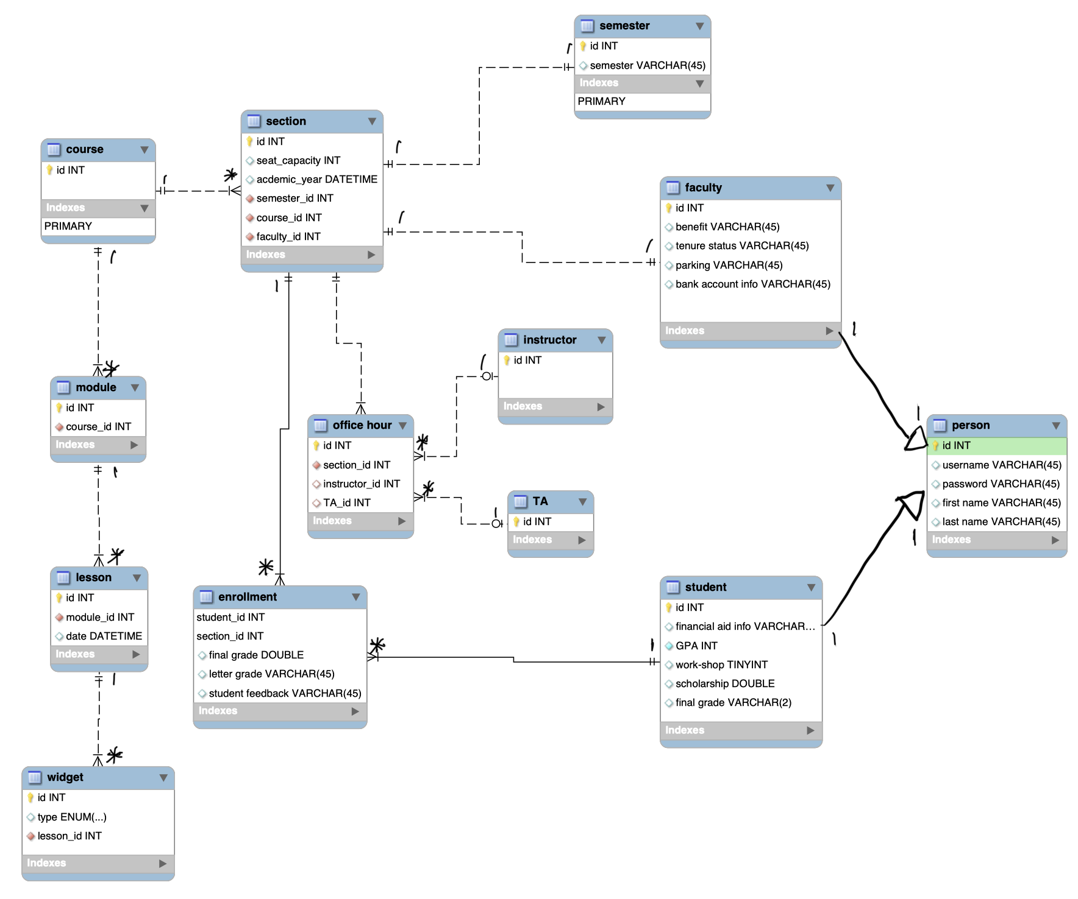

Final diagram:

